**Bangladesh Studies**

# Lecture 2: Notes and Outline

**(Please do not quote and share in public pages)**

**Ancient *Janapada*s of Bengal**

***Vanga* to Bangladesh**

# Pre Literate Phase of Bengal

–Pre Literate Phase is dateable to the 2nd Millennium BCE

* In between 1500-1000 BCE
  + People of Bengal became food producer i.e. started agricultural activities, cattle farming, trading.
  + Pandu Rajar Dhibi, Mahasthan and Wari Bateshwar

–Literate Phase or Historic Age dates back to the 3rd century BCE

* Pre Literate Past are evident through the tools used by human being

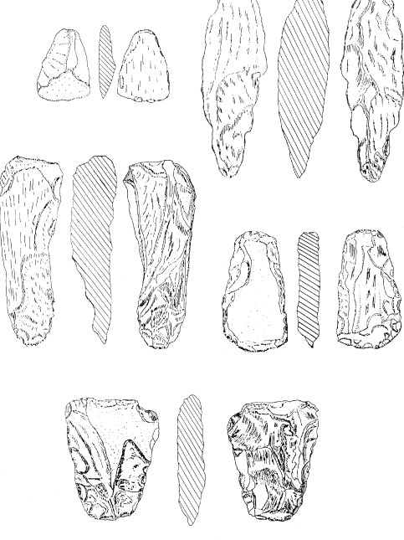 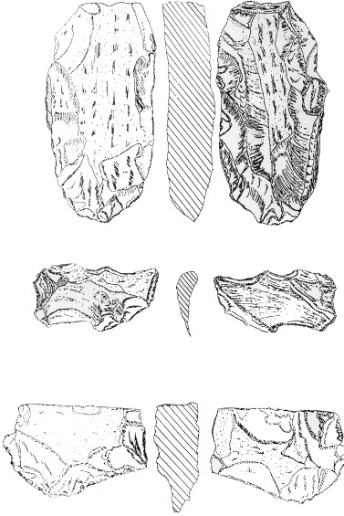

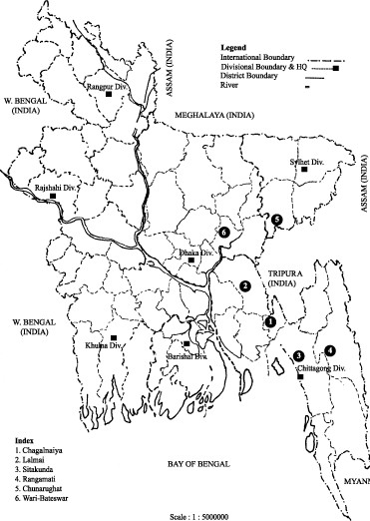

Earliest Written Record: Mahasthan Brahmi Inscription

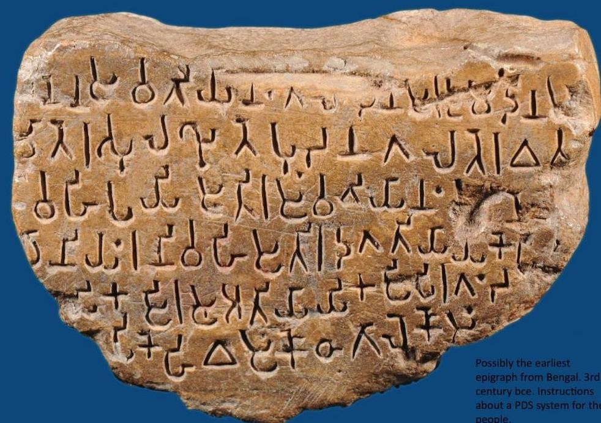

https:/[/www.facebook.com/IndiaHistory/photos/a.111482465535493/2202143503136035/?type=3](http://www.facebook.com/IndiaHistory/photos/a.111482465535493/2202143503136035/?type=3)

### Lalmai-Mainamati Hills

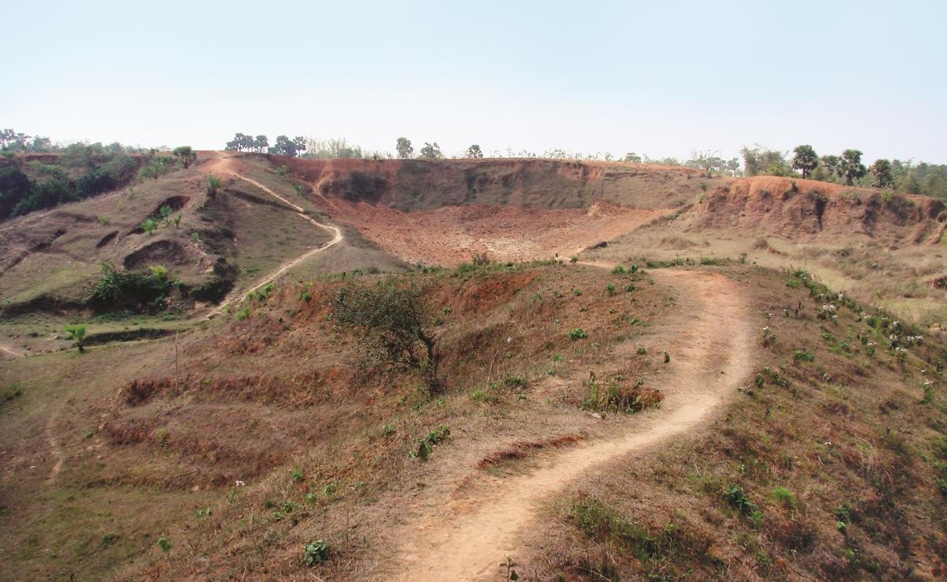

Pre-neolithic Tool Types from Lalmai Hills



Pre-neolithic Tool Types from Lalmai Hills

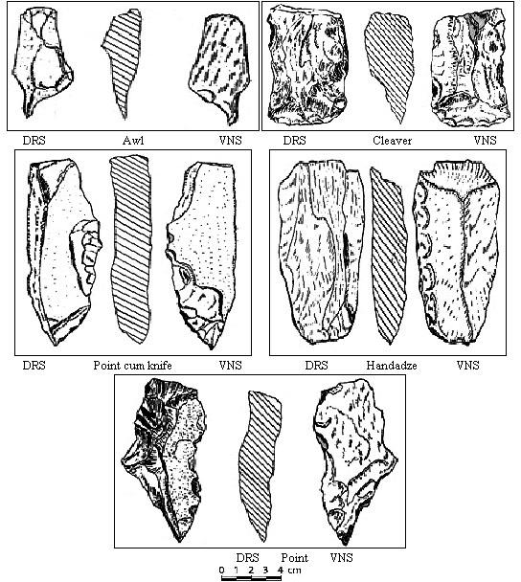

Neolithic Tool Types from Lalmai Hills

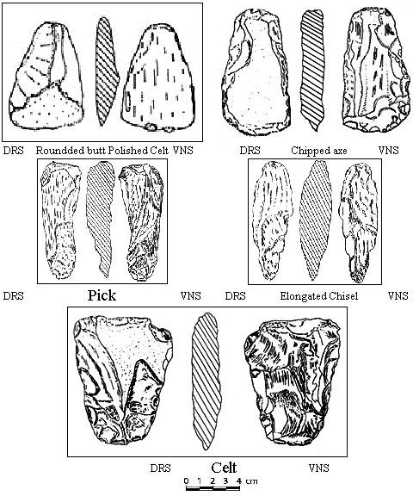

### Hand axe found from Lalmai

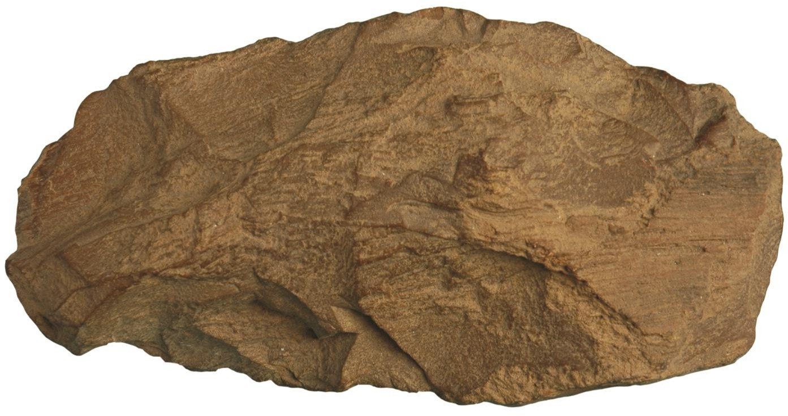

##### Neolithic tools found from Wari-Bateshwar



Photo: Sufi Mostafizur Rahman

**Neolithic tools found from Wari-Bateshwar**

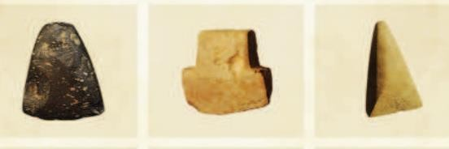

Photo: Sufi Mostafizur Rahman

##### Neolithic tools found from Wari-Bateshwar



Photo: Sufi Mostafizur Rahman

Ancient *Janapada* of Bengal

* What is Janapada?
  + *Jana* mean People
  + *Pada* means leg

##### Foothold of a people

* A place where people kept their legs i.e. settled themselves from the nomadic way of living.

**Ancient *Janapada*s of Bengal**

* Pundra
* Gaur
* Varendra
* Rarh
* Vanga
* Samatata
* Harikela
* ***Absence of Cartographic records to understand the territorial demarcation is the greatest challenge for historians***
* These *Janapada*s are also known as sub-regions or geo-political units.
* They were possibly never unified under a single paramount political power in the pre-1200 CE phase.
* The division of *Janapada*s to a great extent was created by the course of the great rivers of Bengal.
* Their boundaries often varied with the variation of the river courses as also with the extension or reduction of political influence of the units or sub-regions (*Janapada*s)

Ancient *Janapada*s: Pundra

* This Janapada originally denoted northern part of Bengal, i.e. Rajshahi-Bogra-Dinajpur areas of Bangladesh and part of northern sector of West Bengal, India
* In Ancient land records it was mentioned as

*Pundravardhana Bhukti*

* The name is based on the name of the tribe Pundra people (*jana*), gradually developed into a territorial unit
* *Pundranagara* identified with Mahasthan, Bogra probably was the center of this unit

**For further reading please follow the link**

[*https://en.banglapedia.org/index.php?title=Pundranagara*](https://en.banglapedia.org/index.php?title=Pundranagara)

Ancient *Janapada*: Varendra/Varendri

* + Another geographical unit
  + Which was co-extensive with large tracts of North Bengal,
  + In the *Ramacarita* of Sandhyakaranandi (written in the 12th century CE), it is stated that *Varendramandala* forms the best part of the world, and *Pundravardhana* is its crest- jewel (*varendri-mandala-churamani*)

**For further reading please follow the link**

<https://en.banglapedia.org/index.php?title=Varendra>

Ancient *Janapada*s: Gaur

* This was an important geo-political entity in Bengal
* the Gaur *janapada* comprised areas of Malda- Murshidabad, Birbhum and Bardhaman of West Bengal, India.
* During the reign of King Shashanka its sway extended both northward and southward.
* Karnasubarna was the capital of Shashanka; identified in the Rajbaridhanga, Murshidabad District, West Bengal
* Kings of Gaur took the title *Gauresvara*

[https://en.banglapedia.org/index.php?title=Gauda,_Janapada](https://en.banglapedia.org/index.php?title=Gauda%2C_Janapada)

Ancient *Janapada*s: Rarh

* + This *Janapada* roughly denoted areas to the west of the Bhagirathi, i.e. the present districts of Birbhum, Bankura, Bardhaman, Hughly, Howrah and Medinipur in West Bengal.
  + It means that Rarh probably included a large part of the Indian state of West Bengal.
    - Geographically, it is constituted by lateritic old alluvium flanked by the coalesced fans of rivers Ajay, Damodar, Rupnarayan and Kasai, and the moribund and mature deltas along Bhagirathi-Hughly River.
    - It is bordered by the Rajmahal and Chotanagpur hill tracts on the west.
    - Padma and Bhagirathi rivers demarcate it from the other sub-units

Ancient *Janapada*s: Vanga

* This unit is bounded by the two wings of the Ganges
* It included the area covering modern districts of 24- Parganas (both north and south), Hughly, Howrah and Medinipur and parts of Bardhaman (and also parts of Birbhum, Bankura and Nadia) and the coastal region of present Bangladesh up to the mouth of the Padma (or the joint streams of the rivers Padma, Brahmaputra, Meghna and Yamuna).
* It constitutes the main part of the Bengal delta
* The boundaries of Vanga have changed from time to time

**For further reading please follow the link**

<https://en.banglapedia.org/index.php?title=Vanga>

Ancient *Janapada*s: Samatata

* + It was a flat coastal land
  + A well demarcated ancient *Janapada* located in the southeastern part of Bengal.
  + This territorial unit roughly corresponded to the region east of the River Meghna, i.e. Noakhali, Comilla, Chittagong and adjacent areas in present Bangladesh and some parts of present Tripura in India

**For further reading please follow the link**

<https://en.banglapedia.org/index.php?title=Samatata>

**Ancient *Janapada*s: *Harikela***

* + It was another distinct unit in the Trans- Meghna region,
  + A separate political entity in the coastal tract of Chittagong and its neighboring areas.
  + the capital of *Harikela* has been identified with present *Vara-uthan* or *Borodhan* village of Patiya Upazila in Chittagong district
  + With the growth of political power, the limits of Harikela kingdom extended to incorporate areas of Noakhali, Comilla, Tripura and Sylhet.
  + The inclusion of these territories within Harikela gave it a fairly well-defined natural boundary:
  + the Bay of Bengal to its south, hill tracts of Chittagong, Tripura, Cachar and the Lushai hills to its east and north-east and Jaintia hills to the north, the Meghna and the Surma formed its western boundary.

**For further reading please follow the link**

<https://en.banglapedia.org/index.php?title=Harikela>

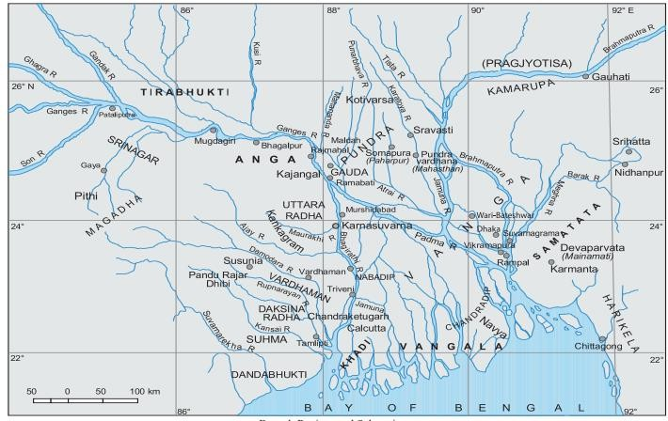

* + - But it must be said that it is not possible to make any water tight limits between *Samatata* and *Harikela*.
    - It is generally held that Comilla-Noakhali area formed the core territory of *Samatata*, while the coastal tract of Chittagong formed *Harikela’s* core

##### Vanga to Bangladesh *Vanga* to Bangladesh

**An Etymological Journey**

* Ancient *Janapada*s of Bengal were: Pundra, Gaur, Varendra, Rarh, Vanga, Samatata, Harikela
* Among these Vanga-Harikela-Samatata was located within the border of present Bangladesh
* Pundra-Varendra was spread over the Northern part of Bangladesh and it includes few parts of West Bengal, India.

????

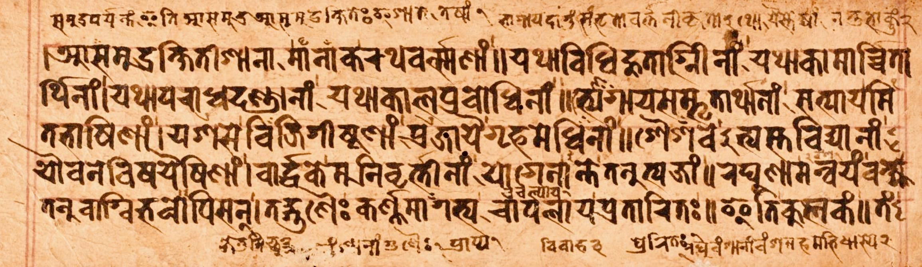

Kalidasha’s *Raghubamsha* (4th-5th century)

* + The mighty Raghu had fight with the people living in Vanga region.
  + He exterminated the *Vanga*s
  + Vanga was located between the extreme mouths of the Ganges
  + They were very skilled in Naval Fighting
  + Raghu then set up pillars of victory in the islands situated in between the channels of the Ganges (the Bhagirathi and the Padma)
* 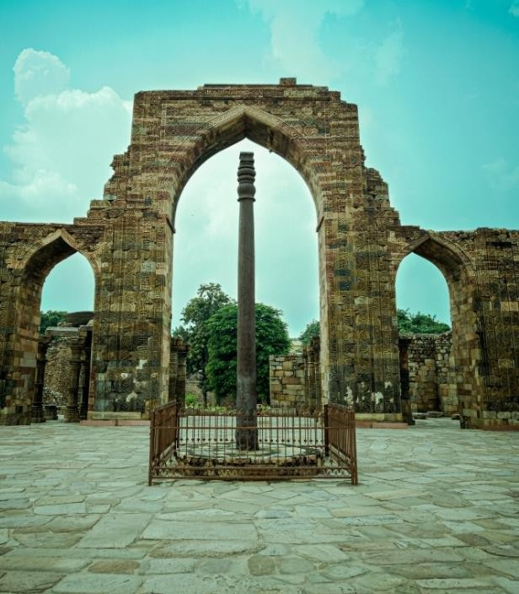The Meherauli Iron Pillar Inscription of king Candra mentioned the conquest of Vanga-Samatata area (land watered by the lower streams of the Ganges).

## Vangaladesha:

#### A name found in Chola Inscription

* + The name is found in a south Indian Chola Inscriptions called the Tirumulai inscription of Rajendra Chola’s (1012- 1044 CE)
  + It records and expedition sometime before 1024 CE, and roughly between 1021 CE and 1024 CE.
* Its apparent object, as expressed in the Chola records, was to bring the holy water of the Ganges in order to sanctify his own kingdom.
* The Cola general destroyed Dharmapala in a fierce battle.
* The Chola army forcibly attacked *Vangaladesha*,
* It is a land where the rain water never stopped,
* The King of *Vangaladesha* was Govindacandra, who fled from his kingdom instead of resisting the Chola attack

***Bangalah***

* Sultan Shamsuddin Iliyas Shah united Satgaon, Lakhnauti and Sonargaon by the middle of the 14th century and came to be known as ***Shah-i-Bangalah***
* 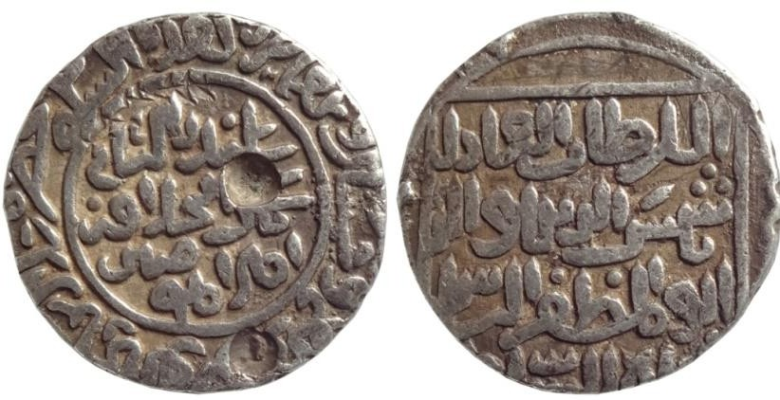From that time onwards the whole of Bengal was under a unified rule and came to be known as ***Bangalah.***

**For further reading please follow the link**

<https://en.banglapedia.org/index.php?title=Bangalah>

## AbulFazlPresentingAkbarnama.jpgSubah Bangala

* + The Mughal Provinces were known as *Subah*
  + It was one of the Province of Emperor Akbar
  + Abul Fazl, the court historian of Akbar wrote that Bengal was one of the fifteen *subah*s of the Mughal Empire
* Abul Fazl mentioned a very important factor regarding the naming of the ‘*Subah Bangala*’that:
* The original name of Bengal was *Banga*.
* Its former rulers raised mounds throughout the province which were called *Al* (embankment)
* From this suffix, the name *Bangala* took it rise and currency

#### Bengal Province of the British India

* British Province of Bengal included Bihar and Orissa since 1765 CE
* It was admittedly much too large for a single province of British India.
* It was divided in 1905, which known as The Partition of Bengal, 1905
* Before the Partition Bengal Province covered an area of 189,000 sq miles
* In 1903 the population of the province was 78.50 million

#### Eastern Bengal and Assam Province

* + The capital was set up at Dhaka and subsidiary headquarters at Chittagong.
  + It covered an area of 106,540 sq. miles with a population of 31 million comprising 18 million Muslims and 12 million Hindus
  + A clear division between these two communities was created by the British administrators of India.

# East Bengal

* On 15 July 1947, the Indian Independence Act of the British Parliament ended the British rule in India on 15 August 1947.
* It also stipulated that the partition of India into two sovereign dominions : India and Pakistan.
* East Bengal and West Pakistan formed the state of Pakistan
* The power was finally officially transferred to Pakistan and India on 14 and 15 August respectively

# East Pakistan

* + East Pakistan was renamed from East Bengal in 1955
  + Pakistani Prime Minister Mohammad Ali actively operated this reform
  + One Unit programme: It merged the four provinces of West Pakistan ( West Punjab, Sind, NWFP and Baluchistan) into one single province
  + The act was passed 30 September 1955 in the

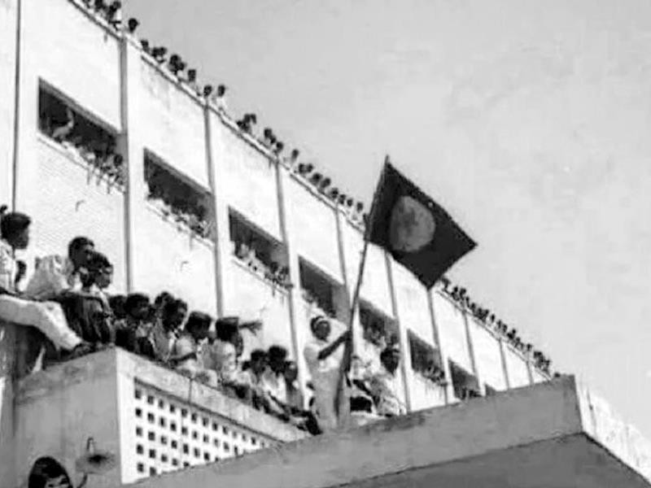

**March 2, 1971 Faculty of Arts University of Dhaka**

### The independence of Bangladesh was declared in 26 March, 1971 and after a fierce battle the victory came on 16 December 1971.

**For further reading please follow the link**

[**https://en.banglapedia.org/index.php?title=Political_Geography**](https://en.banglapedia.org/index.php?title=Political_Geography)